Space Physic

Nighttime   
Plasma Depletion Bay   
observed by FORMOSAT-3

Author:歐陽明崴, OU YANG,MING-WEI

Student number:405290058

Abstract

Plasma Depletion Bay is a phenomenon that appears at North Atlantic, Indian Ocean, and Southeast Asia in the northern summer night.

I will use the 2007 and 2008 data of FORMOSAT-3, and plot the global electron density distribution in different time、day、 seasons、and altitude, to study the feature of the Plasma Depletion Bay.

Contents

1. Introduction 4

1.1 Research motivation 4

1.2 Research purpose 4

1.3 Research method 4

2. Data analyze 5

2.1 Nc file 5

2.2 Preprocess 6

2.3 Electron density distribution 6

3. Monthly Variation (time 0~7) (altitude 250~400) 7

3.1 2007 vs 2008 7

4. Four seasons electron density distribution 8

4.1 Four seasons 8

4.2 $March equinox$ (time 23,0,1) (altitude 250~300) 8

4.3 $September equinox$ (time 23,0,1) (altitude 250~300) 8

4.4 $June solstice$ (time 23,0,1) (altitude 250~300) 9

4.5 $December solstice$ 9

4.6 seasons summary 9

5. Altitude variation (250~400) 10

5.1 June solstice 10

5.2 December solstice 11

5.3 Altitude variation’s summary 11

6. Altitude – longitude plot (altitude 200~600) 12

6.1 2007 June solstice 12

6.2 2008 June solstice 13

7. One day variety 14

7.1 June solstice 14

7.2 December solstice 15

7.3 One day’s summary 15

8. Conclusions 16

9. Reference 16

1. Introduction

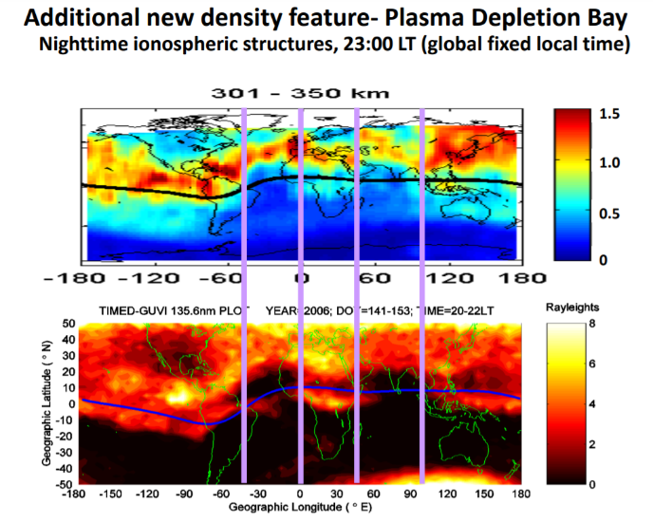1.1 Research motivation

We notice that in the summer evening, the ionization concentration in the three regions was abnormal, we call it Plasma Depletion Bays.

1.2 Research purpose

We want to study its formation mechanism and time more deeply.

1.3 Research method

Use satellite-FORMOSAT-3’s data, and use the programming language-Julia for analyze.

FORMOSAT-3, a satellite launched in April 2006, and Retire in May 2020.

Julia is a high-level, high- performance, dynamic programming language, it has many features and advantages of programming languages, claiming to be as easy to learn as Python, but also with the high performance of C. Julia has been widely used in various fields, including today's popular data science.

1. Data analyze
   1. Nc file

FORMOSAT-3’s data is store in the NetCDF-file, we need to use a special module to read it, there have several different variables to be store in it. What we will use is GEO_lat、GEO_lon、time、ELEC_dens, and MSL_alt, which is corresponding to latitude, longitude, UT time, electron density, and altitude.

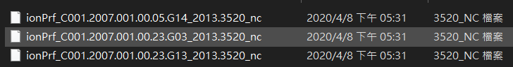

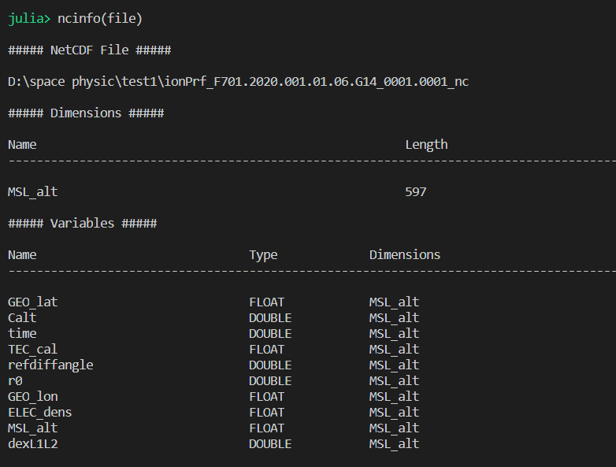

* 1. Preprocess

Reading file by file is too slow, so I merge it into the CSV file.

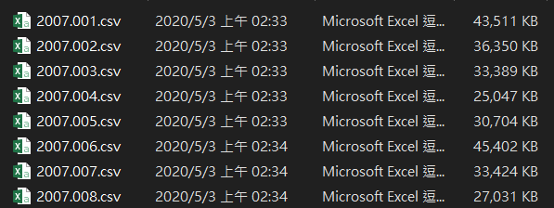

* 1. Electron density distribution

We have the electron density at each latitude and longitude, if there are enough databases, we can plot a global electron density distribution map.

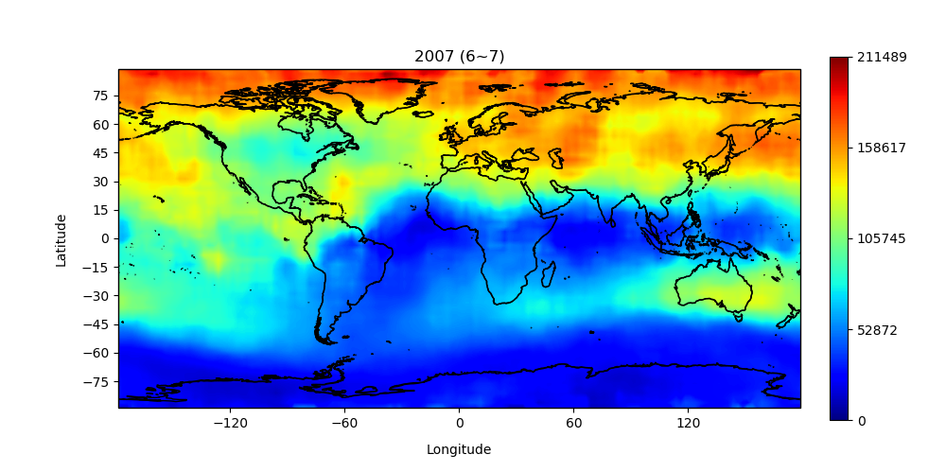

$$▲An example of global electron density map$$

1. Monthly Variation (time 0~7) (altitude 250~400)

3.1 2007 vs 2008

$$▼left 2007, right 2008$$

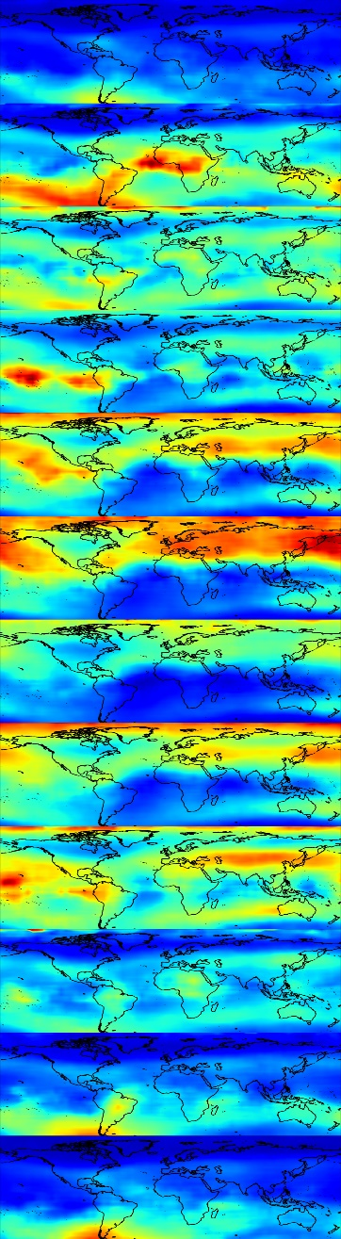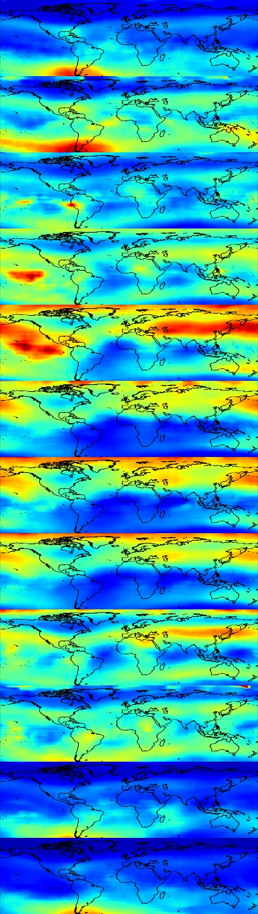

**January**

**February**

**March**

**April**

**May**

**June**

**July**

**August**

**September**

**Octobor**

**November**

**December**

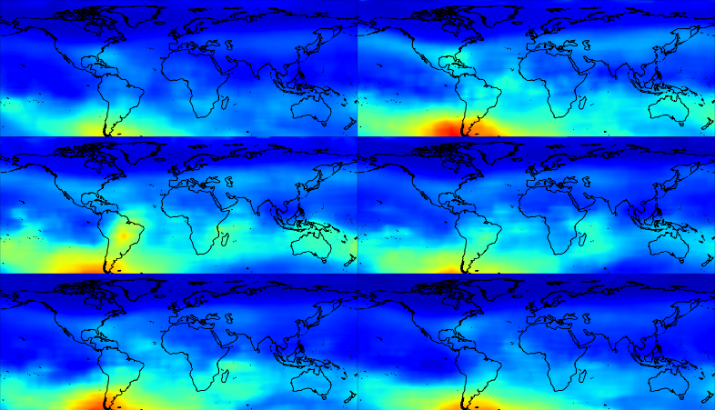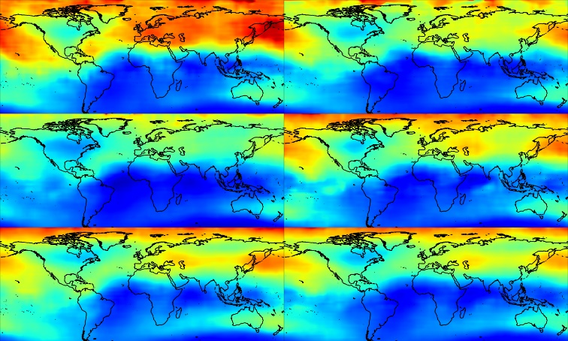

1. Four seasons electron density distribution
   1. Four seasons

We will take 45 days before and after the equinox and solstice.



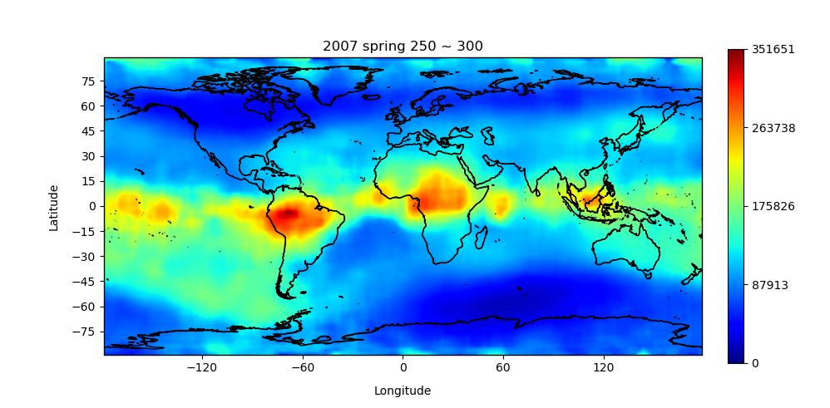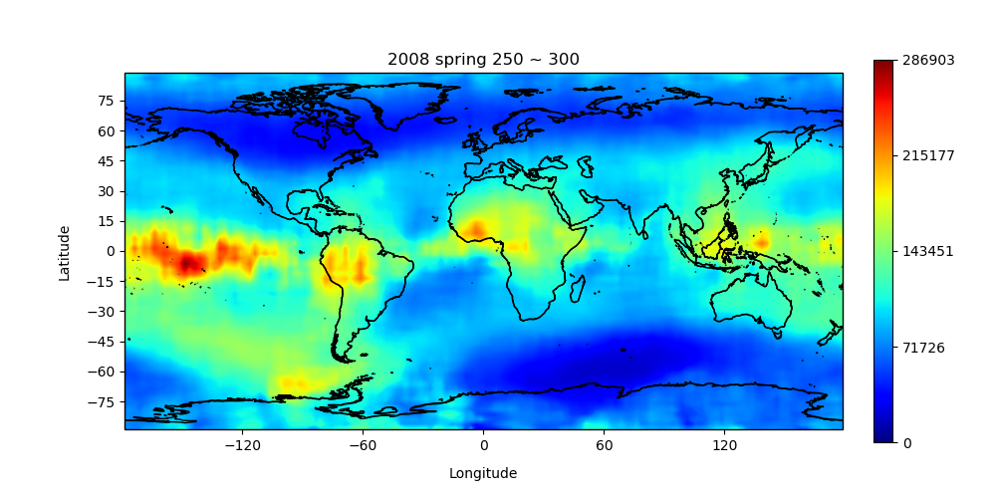

* 1. (time 23,0,1) (altitude 250~300)
  2. 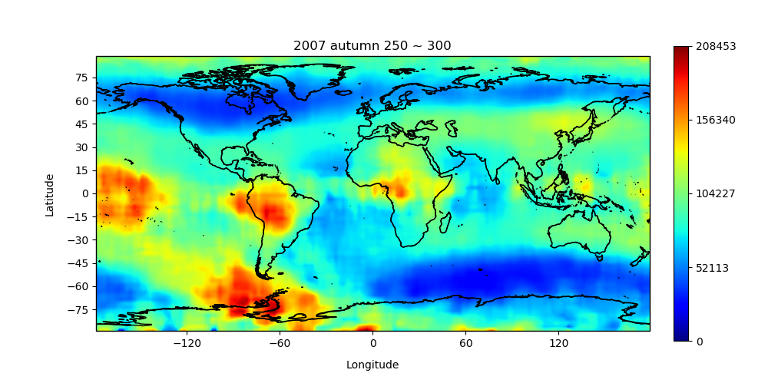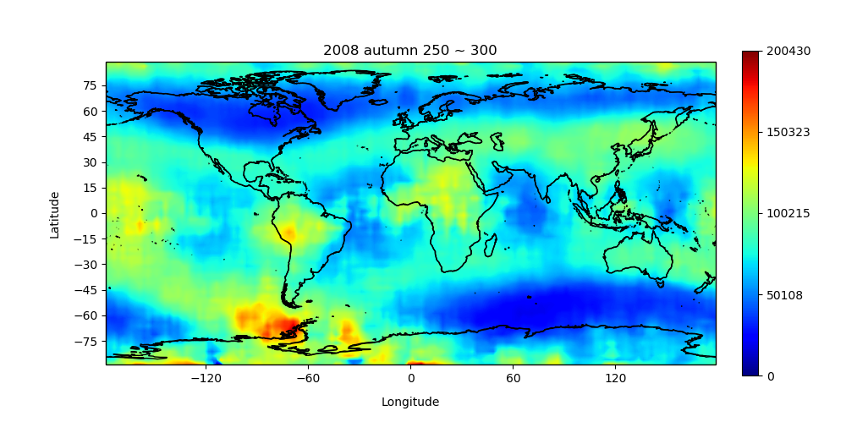 $September equinox$ (time 23,0,1) (altitude 250~300)

$$▲no plasma depletion bays$$

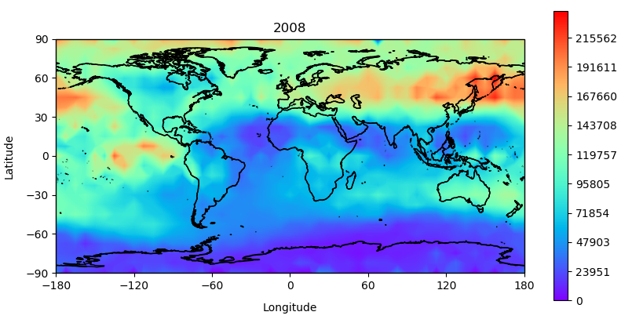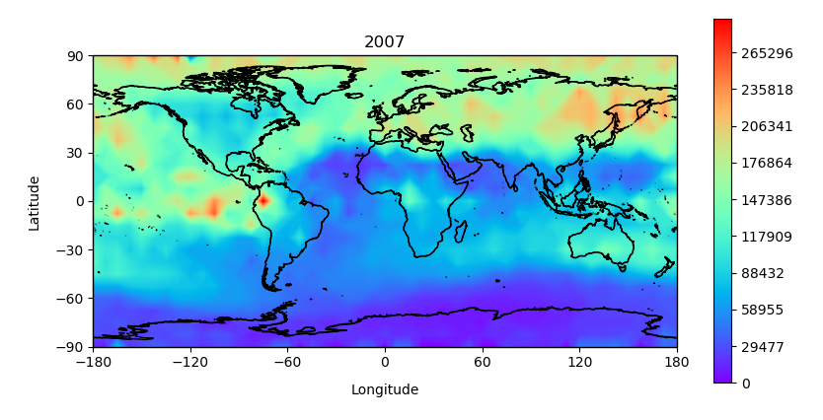4.4 $June solstice$ (time 23,0,1) (altitude 250~300)

$$▲plasma depletion bays appears$$

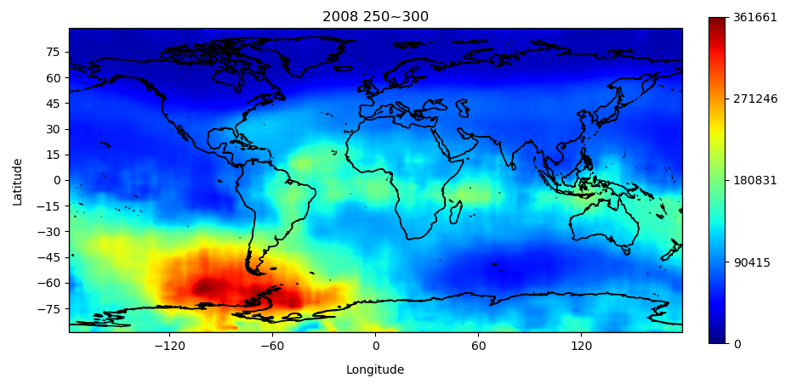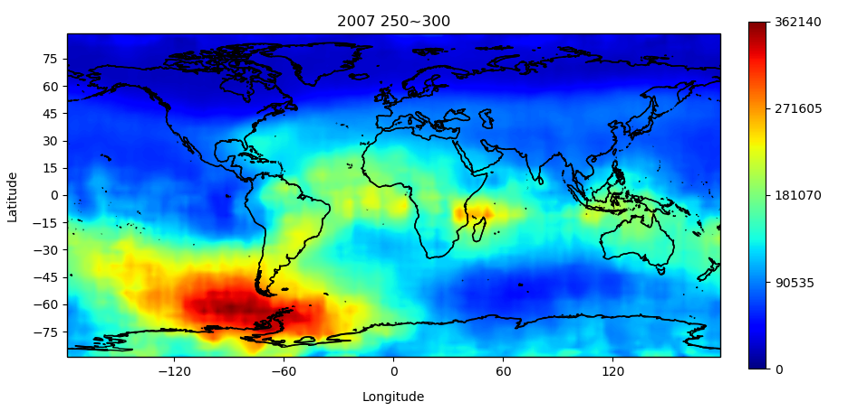4.5 $December solstice$ (time 23,0,1) (altitude 250~300)

$$▲plasma depletion bays appears$$

4.6 seasons summary

Plasma depletion bays appears in June solstice and December solstice, and disappear in March equinox and September equinox.

1. Altitude variation (250~400)

The altitude’s order is from left to right, top to bottom

* 1. June solstice 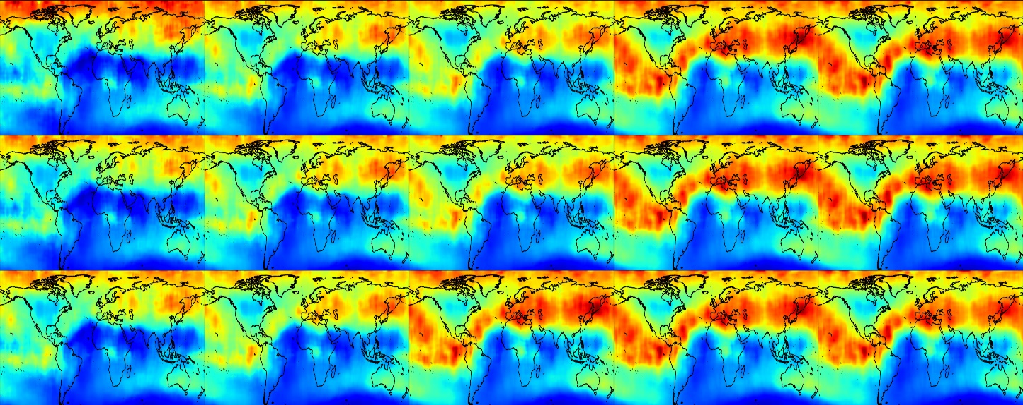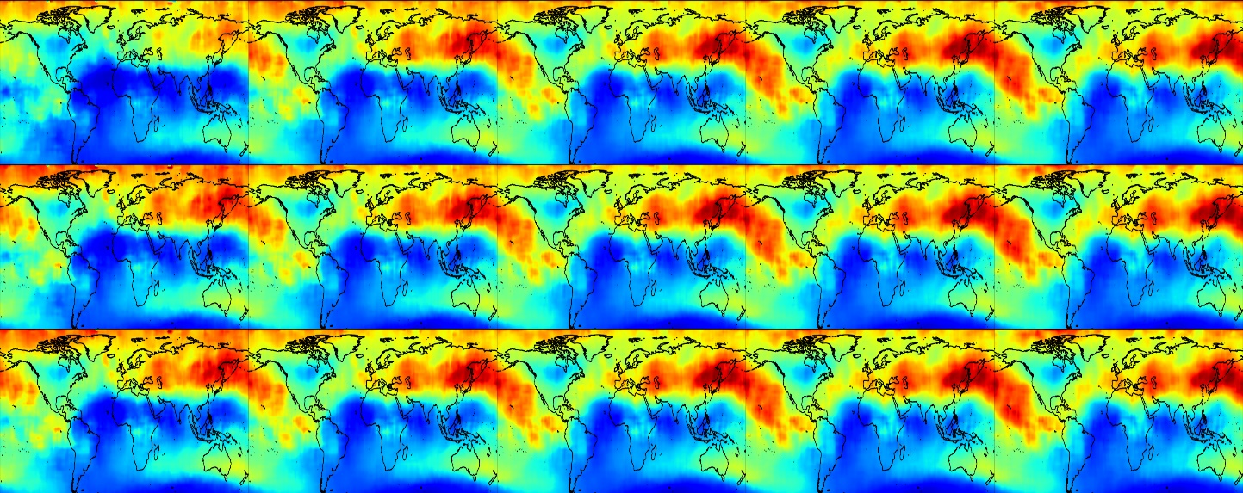
 $$▲2008 summer$$

 $$▲2007 summer$$

2. 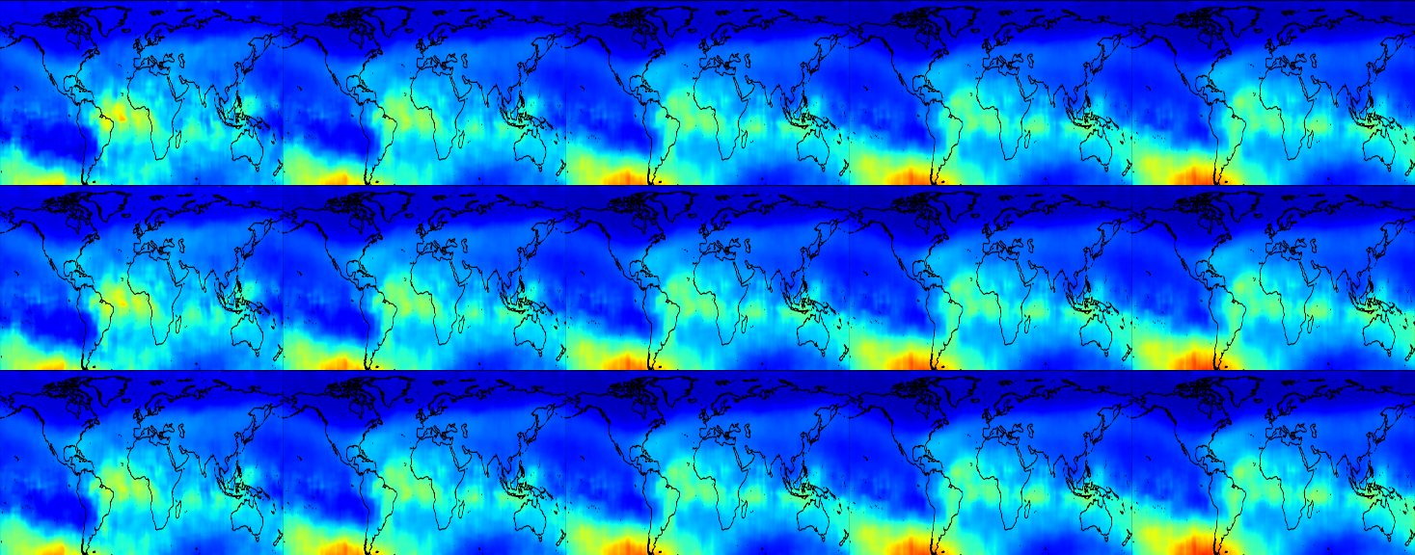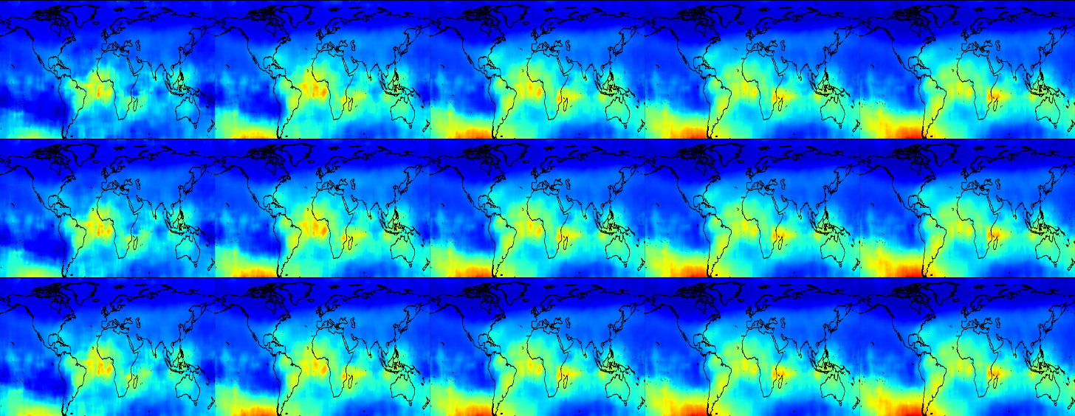December solstice
 $$▲2007 December soltice$$

 $$▲2008 December soltice$$

3. Altitude variations summary

If you look carefully, you can notice that the PDB will approach the equator with the altitude become higher.

1. Altitude – longitude plot (altitude 200~600)

6.1 2007 June solstice

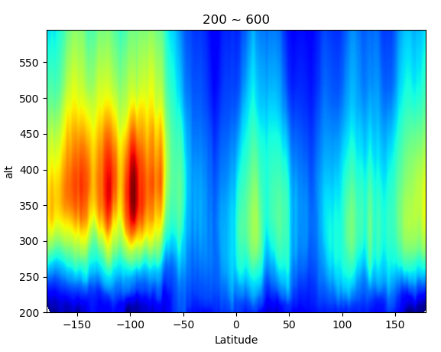



6.2 2008 June solstice

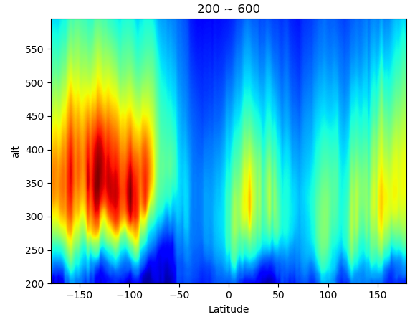

1. One day variety

* 1. June solstice

**0~1**

**2~3**

**4~5**

**6~7**

**8~9**

**10~11  
12~13**

**14~15**

**16~17**

**18~19**

**20~21**

**22~23**

$$▼left 2007, right 2008$$

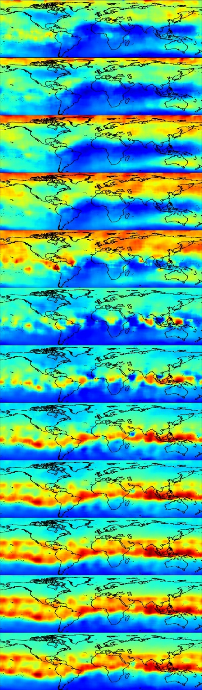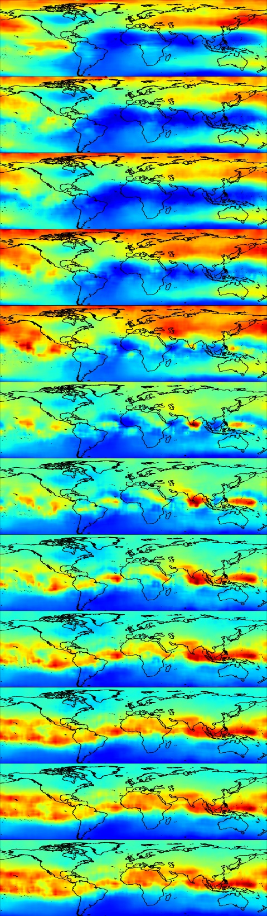

7.2 December solstice

$$▼left 2007, right 2008$$

**0~1**

**2~3**

**4~5**

**6~7**

**8~9**

**10~11  
12~13**

**14~15**

**16~17**

**18~19**

**20~21**

**22~23**

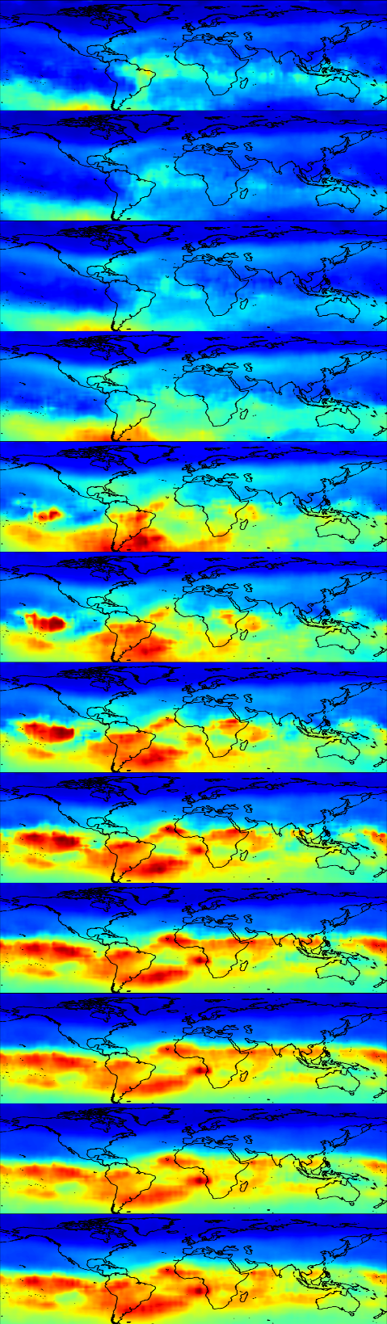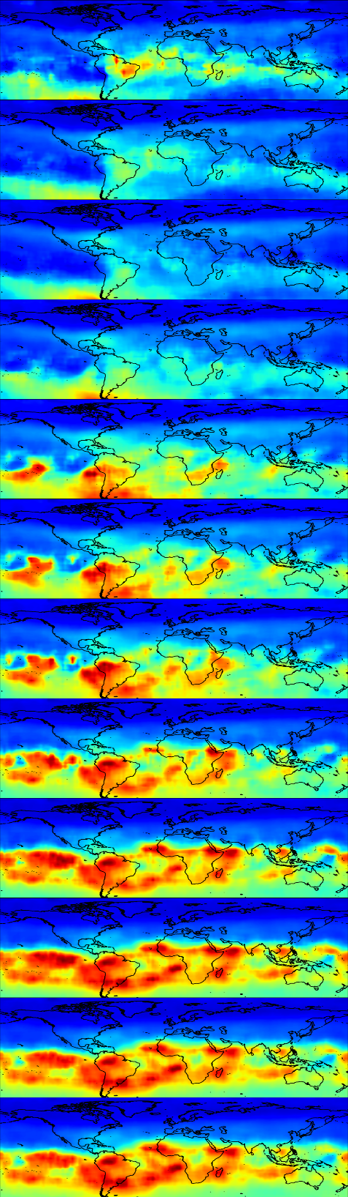

* 1. One day summary

PDB appears in 0000~0700LT.

1. Conclusions
2. PDB distributed in the North Atlantic, Indian Ocean, and Southeast Asia in the northern summer.
3. It is distributed in the Pacific Ocean in the southern summer.
4. As the altitude becomes higher, the PDB will approach the equator.
5. It appears at 0000 ~ 0700 LT and disappears during the day.
6. Reference
7. <https://irsl.ss.ncu.edu.tw/media/course/107107年第1學期中央大學高等太空科學/2018_ASS_Ionosphere-converted.pdf>
8. <https://ui.adsabs.harvard.edu/abs/2018AGUFMSA31B3430C/abstract>
9. <https://ndltd.ncl.edu.tw/cgi-bin/gs32/gsweb.cgi?randomimg=GwgKtv_1593191963&validpath=%2Ftmp%2F%5Enclcdr__doschk%2FGwgKtv_1593191963__ZGRrYzRy&validinput=ddkc4r&check=%E7%A2%BA%E5%AE%9A>